Bug Description
Hardcoded secrets Hardcoded secrets are the habit of storing sensitive data, e.g. API keys, passwords, tokens, or security configuration flags, in the source code of the application itself. This falls in Security Misconfiguration, which is the #5 in the OWASP Top 10. It is an incredibly widespread error, especially amongst novice developers, and perhaps one of the most common reasons of cloud account breaches and data leaks in applications in the real world.
How the Bug Was Identified
In this exercise, an imaginary server setup was coded in Python and installed secrets were hard coded into the script:
API_KEY = "sk-1234567890abcdef"
SSL_ENABLED = False
DEBUG_MODE = True
There are three different issues at hand. First, API key may be seen by any individual human or automated tool that inspects the source code. Second, the default value of the key, SSLE_ENABLED = False, deactivates encrypted communication, exposing the application to the man-in-the-middle (MITM) attacks where an attacker listens to the network traffic. Third, DEBUG_Mode = True reveals internal error messages, stack traces and system paths to end users which provides attackers with a detailed map of the system.
How the Bug Was Fixed
This fix had three modifications:
- The API keys were transferred to environment variables in Python with the help of the os.environ.get() method — the secret is not included in the codebase, but rather in a .env file, which is not contained in version control due to .gitignore.
- SSL was implemented by making ssl_enabled = True.
- Disabling debug mode, debug_mode = False.
import os:
api_key =os.environ.get( API_KEY, NOT SET)
ssl_enabled = True
debug_mode = False
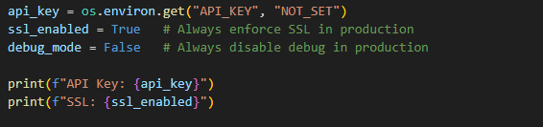
Conclusion
Hardcoded secrets Hard coded secrets are of high severity and can compromise a whole application without any hacking skills whatsoever, just by reading the code. The application will no longer display the credentials in the source code by setting environment variables and strictly making only secure defaults. This is a basic security concept suggested by OWASP and embraced by all professional development teams.

